Project Documentation
Project Title
- Amazon Prime TV Shows and Movies
Dataset Name
- titles.csv
- credits.csv
- cleaned_data
Dataset Description
The dataset contains information about movies and TV shows available on Amazon Prime Video. It includes data related to each title, such as content type, release year, genres, runtime, age certification, IMDb rating, TMDB rating, and production details.

Dataset Fields
- person_id
- id
- name
- character
- role
- title
- type
- description
- release_year
- age_certification
- runtime
- genres
- production_countries
- seasons
- imdb_id
- imdb_score
- imdb_votes
- tmdb_popularity
- tmdb_score

This dataset was merged, cleaned and transformed using Python before importing it into Power BI for visualization.
Dashboard Objective
The objective of this dashboard is to provide an interactive analysis of Amazon Prime Video's content library. It enables users to explore content distribution, ratings, runtime, release trends, and audience certifications using dynamic filters and visualizations.
The dashboard helps answer important business questions such as:
- How many movies and TV shows are available?
- Which type of content dominates the platform?
- How has content production changed over time?
- Which age certifications are most common?
- Which content type receives better audience ratings?
- What is the average runtime of movies and TV shows?
Dashboard Screenshot

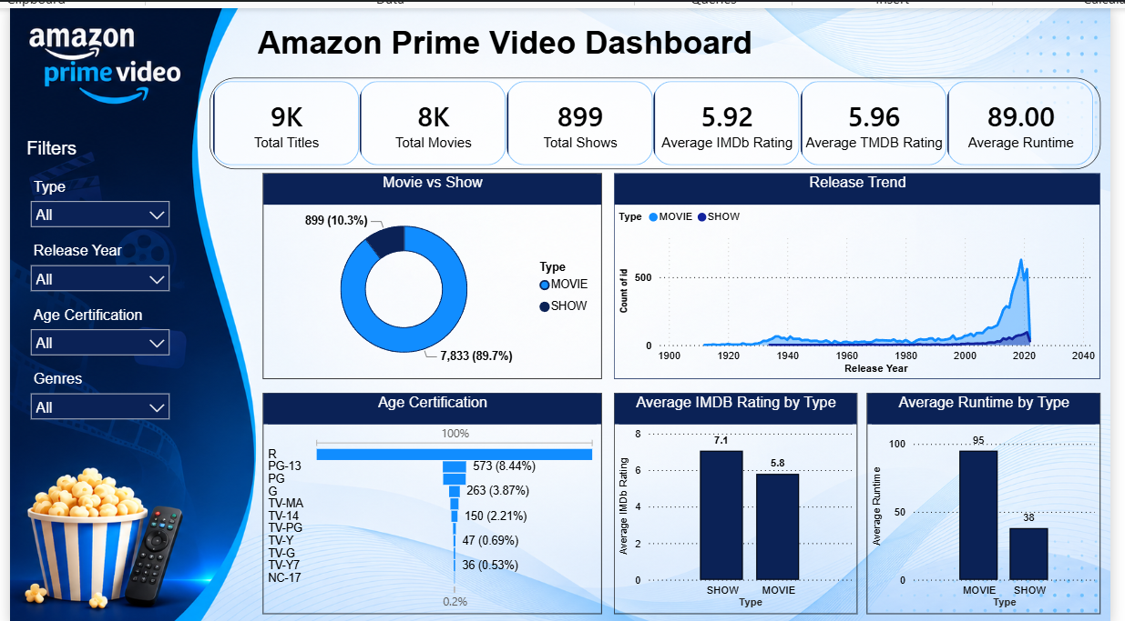
Dashboard Components
- Interactive Filters
The dashboard includes four slicers that allow users to filter data dynamically:
- Type
- Release Year
- Age Certification
- Genres
These filters make the dashboard interactive and enable customized analysis.
- Visualizations
- KPI Cards
The dashboard displays six KPI cards that provide a quick summary of the dataset:
- Total Titles
- Total Movies
- Total Shows
- Average IMDb Rating
- Average TMDB Rating
- Average Runtime
These KPIs give users an immediate overview of the platform.

- Movie vs Show (Donut Chart)
Purpose
Displays the proportion of Movies and TV Shows.
Insight
- Movies account for nearly 90% of the total content.
- TV Shows make up approximately 10%.

- Release Trend (Line Chart)
Purpose
Shows the number of titles released over time.
Insight
- Content production increased significantly after 2010.
- Peak growth occurred between 2018 and 2021.

- Age Certification (Bar Chart)
Purpose
Shows the distribution of titles based on audience certification.
Insight
- R-rated content dominates the platform.
- PG-13 and PG are also common categories.
- Children's content is comparatively smaller.

- Average IMDb Rating by Type
Purpose
Compares average IMDb ratings between Movies and TV Shows.
Insight
- TV Shows have higher average ratings than Movies.
- Although fewer in number, TV Shows receive stronger audience appreciation.

- Average Runtime by Type
Purpose
Compares the average runtime of Movies and TV Shows.
Insight
- Movies average around 95 minutes.
- TV Shows average around 38 minutes.

Key Insights and Explanations
- The platform contains approximately 9,000 titles.
- Movies dominate the content library with almost 90% of all titles.
- TV Shows represent only around 10% of the catalog.
- The average IMDb rating is 5.92, while the average TMDB rating is 5.96, showing consistency between rating platforms.
- Most content was released after 2010, indicating rapid expansion of the content library.
- R-rated content is the most common age certification, suggesting a strong focus on mature audiences.
- TV Shows receive better audience ratings than Movies despite being fewer in number.
- Movies have significantly longer runtimes than TV Shows.
Business Impact Summary
This dashboard provides valuable insights that can support business and content strategy.
Business Benefits
- Understand audience content preferences.
- Monitor content growth over time.
- Identify high-performing content categories.
- Support strategic decisions for future content acquisition.
- Improve investment planning for original productions.
- Enhance content portfolio management through interactive analytics.
Recommendations
- Increase investment in TV Shows, as they receive higher audience ratings.
- Expand family-friendly and children's content to attract a broader audience.
- Continue growing the content library with high-quality original productions.
- Use audience ratings to prioritize future acquisitions and licensing decisions.
Tools and Technologies Used
- Python (Data Cleaning & Preprocessing)
- Pandas
- NumPy
- Power BI
- DAX
- Microsoft Excel
- CSV Dataset

Dashboard Link:
https://github.com/suhelsk8msk/Amazon-prime-video-analysis

Video Link

https://drive.google.com/file/d/12O4n_dU7Olv_Z8MMXh2sQro2JjFlTmP7/view?usp=sharing

Conclusion
The Amazon Prime Video Content Analysis Dashboard provides a comprehensive overview of the platform's content library through interactive visualizations and KPIs. It enables users to explore trends, compare content types, evaluate ratings, and analyze audience certifications. The dashboard supports data-driven decision-making by presenting actionable insights in a clear and user-friendly format, making it valuable for content managers, business analysts, and decision-makers.

Author
Mohammad Suhel
Data Analyst | MCA Postgraduate
📧 Email: suhailsk8msk@gmail.com
💼 LinkedIn: https://www.linkedin.com/in/mohammad-suhel-8b509a284/
💻 GitHub: https://github.com/suhelsk8msk

